New Baby

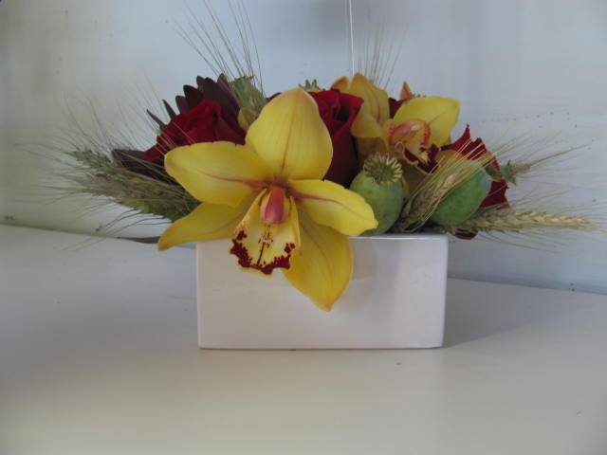

$75.00 Vase

$50.00 Arrangement

$30.00 Hand-tied Bouquet



$200.00 Mom & Baby

$100.00 Deluxe Mom & Baby

$100.00 Deluxe Vase

**Why not flowers for Mom and a bear for the baby.**

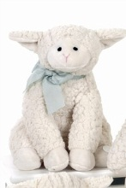

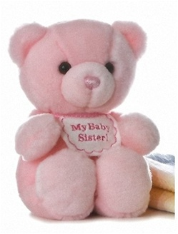

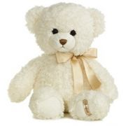



$30.00

$27.00 Bouquet

$28.00

$24.00.00

**Remember the siblings. They will feel part of the action with a lovely bear.**